Taking a Knee

Abstract
Kneeling was ubiquitous during the recent Black Lives Matter protests that were organised in response the police murder of George Floyd. This transnational gesture was also deployed by mainstream media as a sign of multiracial, coalitional politics, its uniformity supplying state actors with movement material for expressions of unity. Having first situated the protests in relation to anti-Black violence and the national lockdown in the UK, this essay interrogates kneeling’s relation to coalitional politics. Drawing on the Black Radical Tradition, I ask whether this gesture’s stamp of unity neutralised the radical demands of Black Lives Matter. By analysing this gesture’s deployment during a speech by the South London rapper, Still Shadey, I seek to describe a wider gestural economy, figuring this gesture as Black performance in relation to what Rizvana Bradley calls ‘a history of interdicted and coerced movement’. Finally, I argue that the balancing act itself – the difficulty of sustaining a knee – disrupts this gesture’s absorption into state choreography by transmitting a kinaesthetic experience of social mobility. Kneeling’s ‘vibratory potential’, I argue, renews the possibility of a coalitional politics in the face of liberal calls for unity.

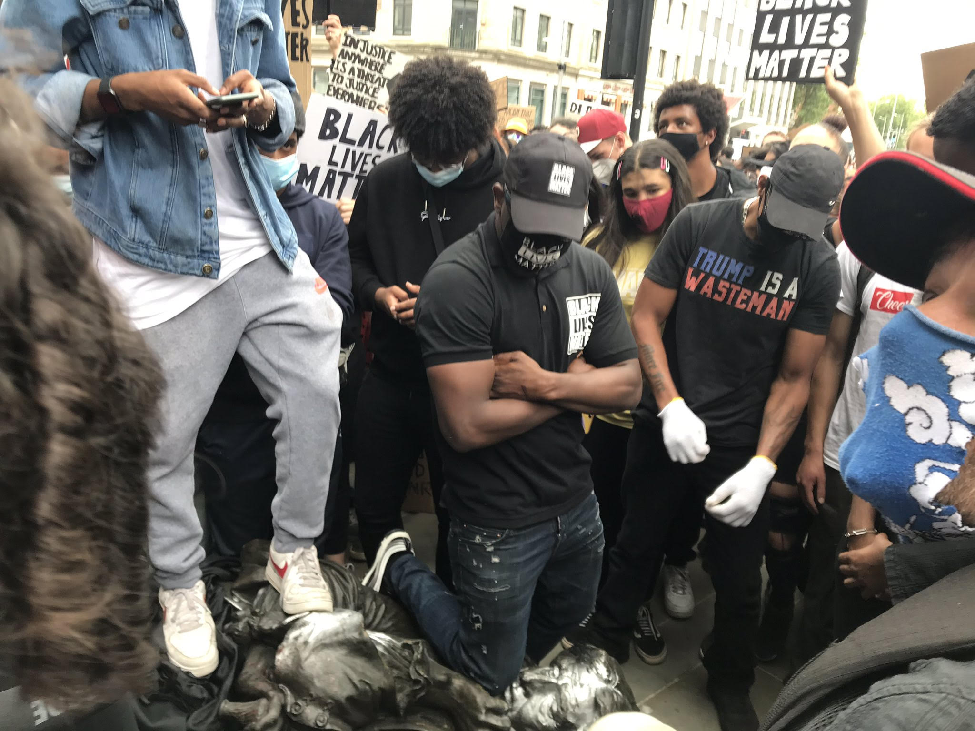
Protesters kneel on the neck of slave trader Edward Colston in Bristol, June 2020 (Twitter).

Introduction
How long have we been screaming change?
A change must come.
Man just walked all the way from west to south you know,
Mans been walking all my life.
This aint nothing new.
This is the life,
This is repeat.
This is the life,
This is repeat.

(Still Shadey)

A livestreamed video records the surround. Amid a welter of banners, protesters, and grey glinting light someone in Still Shadey’s entourage hands him a megaphone. The South London rapper ascends a low brick wall by Vauxhall Bridge during a Black Lives Matter protest in London, June 2020. Shadey’s crew holds a space while he implores those gathered, his face lapsing into a grimace of exhausted consternation as he flows, free hand thrown up to the sky as if animating the refrain then circulating across social media, ‘Enough is Enough’. Stretched and amplified by the tinny speaker, demarcated by italics throughout this essay, his speech culminates with the performative statement: I’m taking a knee today. This is a change. We’re mobilising. The crowd respond in kind, lowering to the tarmac in an act of sombre and defiant contagion; an alliance forms of those who had diverged from the official route leading to the American Embassy in Battersea. In the environment of Shadey’s speech, kneeling crystallised a moment of effervescent solidarity otherwise difficult to achieve under the lockdown’s law of distancing, yet its efficacy remains contested.
In order to sustain this gesture (during vigils for Floyd, the knee was held for 8 minutes 46 seconds) it is necessary to shift one’s weight around the point of contact with the ground by manipulating hips, torso, shoulders, arms, and hands. As such, the doing of it makes clear that the image of unity that kneeling projects is actually comprised of hundreds of embodied negotiations, none of which effectively resolve the position’s tension; yet these negotiations do, when released, serve to renew concentration on the difficult work of taking a coalitional stand. The form of unity kneeling promises remains uncertain: a balancing act.
Drawing on the Black Radical Tradition and contemporary sources, this essay examines kneeling’s tensile relation to politics. How did this transnational gesture, migrating from the US to protests globally, enable alliances to form in the street? Did the viral images of alliance that ensued promote or curtail the demands of Black Lives Matter? Are this social movement’s radical demands neutralised by kneeling’s stamp of unity? The uneasy coexistence of liberalism’s dispossession of Black people and the presence of white protestors is precisely at issue here. A focus on kneeling, this essay argues, makes contact with the strategic difficulty of organising a coalitional movement around specifically anti-Black violence, a difficulty that is augmented in the 2020 mobilisation of Black Lives Matter because of this gesture’s indexical link to the police murder of George Floyd. Taking a knee allowed for a collective witness of violence, yet kneeling was, at the same time, deployed in the protests to express theological values of devotion, respect, and resilience that define a politics of racial uplift, as popularised by the NFL player Colin Kaepernick in 2016. Yes, kneeling indexes the fact of social death, but it also promises and possibly creates a multiracial, coalitional politics linked to Black pride that is not wholly extinguished by the assimilationist agenda of public institutions.
The performance of kneeling, however iconic or mainstream, remains contextually specific and tied to material circumstances. As such, this essay analyses the situation of Shadey’s speech, figuring his performance in relation to the toppling of Edward Colston’s statue in Bristol and coeval vigils for Floyd. Reading for energies of (social) movement amid national lockdown, I turn to resources of gesture theory whose articulation of meaning’s embodied, sometimes contradictory flow is invaluable. Further, I draw on Afropessimist literature to figure kneeling’s agonistic relation to life and death. Indeed, as Christina Sharpe poses in her 2016 book In the Wake, ‘How do we memorialise an event that is still ongoing?’ (20). Or, as Shadey puts it succinctly above, This aint nothing new.
In writing this essay, I hope to situate my own experience as a white Jew of marching, chanting, and silently kneeling while surrounded by banners uncannily stating, ‘White Silence is White Violence’. Empathy is the form of possessive individualism that continues to dispossess Black people in a liberal democracy, yet this does not entirely foreclose radical possibilities from emerging. How might a focus on the gestural economy of kneeling allow for a different understanding of the relationship between coalitional activism and anti-Black violence to emerge? I argue that the kinaesthetic difficulty of balancing while ‘taking a knee’ itself mediates the different meanings produced by this gesture’s appearance in the present conjuncture.

Racism is a Pandemic Too
Why are man beeping their horns and thinking it just started today?
It’s not just when we saw George Floyd,
It’s when we saw the Mark Duggan,
It’s when we saw the Sandra Bland,
It’s when we saw our brothers, and our sisters, in the Law, the Law’s hand.

George Floyd, an unarmed African American man, was murdered by a white police officer on 25 May 2020 in Minneapolis in what was reported to be a ‘modern day lynching’. The violence of Floyd’s murder circulated globally, retraumatising the African diaspora, appalling liberal whites, and galvanising the biggest transnational mobilisation of Black Lives Matter since the movement’s founding in 2013. Against attempts by some media channels to relativise Floyd’s murder, protests in the UK insistently spotlighted the British state’s endemic racism. Protestors shouted the names of Black men and women murdered by the state and the disproportionate, state-sanctioned vulnerability of Black people to Covid-19 was reflected in the slogan ‘Racism is a Pandemic Too’ – organisers handed out masks and insisted that those assembled maintain social distancing. In the United States, protests were organised in rural white areas while in regional cities the socially dispossessed rioted and looted, resisting the police defence of private property. The Minnesota Freedom Fund and other grassroots legal support organisations provided ballast to calls to ‘Defund the Police’ and Instagram surged into a battleground of bootlegged resources, black squares, accusations of posturing, and videos compacting anger, exhaustion, and self-care.
Coming into effect in the UK on 16 March 2020, the first national lockdown reconfigured the social space of the street, rendering proximity to others not only forbidden but undesirable. Yet the virus’s real threat also provided subterfuge for the re-sanctioning of existing forms of racist discrimination; the lockdown’s spacing of social relations extending the compartmentalisation of the street along racial and ableist lines. Furthermore, this zoning was abetted by a new lexicon centred on a grammar of ‘underlying conditions’, and an increase in domestic violence against women was a direct result of the lockdown’s sanctioning logic. As such, the resignification of ‘pandemic’ in the slogan ‘Racism is a Pandemic Too’ served to demystify an expansion of structural racism, demonstrating how the lockdown’s hypervisible regulatory control, rejected as repressive by anti-maskers and anti-vaxxers across the political spectrum, was already in place for Black people as the dominant form of liberal democracy. One year on, the government’s 2021 Race Disparities Report has been widely condemned for its refusal to acknowledge structural racism.
As Saidiya Hartman has written in relation to the Vagrancy Statutes in Harlem, New York, at the turn of the 20th Century,

What mattered was not what you had done, but the prophetic power of the police to predict the future, and anticipate the mug shot… Vagrancy was an expansive and virtually all-encompassing category; like the manner of walking in Ferguson, it was a ubiquitous charge that made it easy for the police to arrest and prosecute young women with no evidence of crime or act of lawbreaking. (Wayward Lives 241)

Hartman’s allusion to Ferguson raises the memory of riotous mobilisations after the police murder of Michael Brown. Appearing suddenly in the author’s ‘critical fabulation’ (Venus in Two Acts 11) of the modern legal apparatus in Harlem, this contemporary allusion posits anti-blackness as a transhistorical imperative that is constitutive of the law under liberal democracy, and riot as a necessary response to it. As narrated by Hartman, the anticipatory form of the Vagrancy Statutes gave carte blanche to police to harass and arrest Black people without cause, a mechanism that is reflected today in the proliferation of stop and search measures – in London, young Black men are 19 times more likely to be stopped than white people (Akhabau). In the above excerpt Still Shadey’s use of the definite article, the Mark Duggan and the Sandra Bland, posits their murders, by police in the UK and the US respectively, as categorical and ongoing. Indeed, Shadey’s speech is exemplary in its figuration of violence as a daily, archaic fact of Black life: he repeatedly shifts from particular to universal, demonstrating the violence of abstraction, It’s not just when we saw George Floyd… It’s when we saw our brothers, our sisters, in the Law. In word and vocal intensity, his exhaustion is obviously a response to Floyd’s murder and the exceptionalism attributed to it, as if this were the incident that made Black suffering grievable; yet, for this reason, it is also symptomatic of the Black community’s response to the overwhelming increase of white recognition for violence against Black people and, in a complicated sense, the presence of white protestors. I want to understand how Shadey’s call for unity, and the performance of kneeling it enacts, responds to the form of liberal democracy described by Hartman.

Kneeling’s ‘Vibratory Potential’
We’re going to do something special; we’re going to take a knee,
Because for once we can build unity.
I’m taking a knee today. I’m taking a knee today.
Whether you’re black, whether you’re white.
Whether you’re Asian, or whether you’re anything, do not be shy.

Something happened on December the 4th. I kneeled down and I prayed.
And I said when I stood, I’m gonna stay for justice.
I’m gonna stand for the sake of God, and so can you!
My first real conversation with God.

Having recounted the murder of his friend on 4 December 2019 amid the loss of many brothers and sisters, Shadey invites those assembled to take a knee. As he lowers himself on the brick wall, megaphone in hand, the camera pans over a wave of kneeling protestors, fists raised in silent response to his call. The uniformity of this gesture, triggered by the quasi-ministerial command we’re going to, evokes a vocabulary of prayer that is compounded by the performance’s break: I kneeled down and I prayed. And I said when I stood, I’m gonna stay for justice. Ascending on the word ‘stood’, Shadey’s enactment of kneeling is organised by a politics of racial uplift transmitted from the early, theologically informed Civil Rights movement.
In an essay concerning Black mobility, Jason King observes that uprightness and verticality have served Black pride as a counter to Black people’s ‘burden of ambivalent direction’ under white supremacy (King 28). Troubling the fixity of uprightness, he advances a genealogy leading from this empowered stance to ‘the cool walk’, which he describes as a state of falling that appears ‘intentionally unintended’ – crucially, in this genealogy, Hip Hop culture would redirect ‘the shame associated with downward mobility into an ethics of pride’ (36–37). King thereby submits uprightness, which I relate to kneeling via their mediation of Black theology, to a dialectics; kneeling, like uprightness, exceeds its iconicity and affirms other, more quotidian or even accidental movements that surround it. As King writes, ‘In Black performance, disorientation […] is the highest form of orientation, uncanny balance and rhythm’ (41). There is, then, a need to read for the effects of kneeling in the surround, in gestures that appear to invert its connotations of devotion, respect, and resilience. Kneeling cannot be separated from moments in Shadey’s speech ‘where shriek turns speech turns song’ (Moten 22), or the forbidden proximity of those assembled in conditions of lockdown; nor can it be disarticulated from the spectacle of “angry” Black men congregating in public space. Kneeling’s apparent uniformity is, in the context of Shadey’s speech, embedded in a wider gestural economy that is legible through codes of Black performance.
In a recent article, Rizvana Bradley reflects on how the state of emergency in which Black people live produces conditions for a different kind of performance to emerge. In particular, she draws a distinction between the choreographic and the gestural in relation to Black social dance, linking this cultural form to a history of activist politics. Bradley argues that where the choreographic disciplines and patterns movement in line with social norms, the gestural describes the body relationally in terms of the ‘heterogeneity and variation of its postures and habits’ (19). She explains that, to the extent that Black people are excluded from the field of ‘human subjectivity’ – a field that, as Giorgio Agamben has posited, is redefined through Modernity by a loss of the gestural – the migratory gesture of Black social dance emerges as capable, via chains of contagion, of disrupting choreographic norms of citizenship (26). For Bradley, the transnational currents of Black social dance, especially as these erupt in the context of protest, have the potential of ‘breaking and bending’ the choreographic; she asserts:

Black bodies in movement have consistently been viewed as threatening; black social dance tends to feature a multitude or swarm of black bodies in their vibratory potential. Black bodies cut movement’s law, drawing us closer to riotous form. In light of such history, black movement might be conceived of as the performance of what Fred Moten calls the “sociopoetics of the riot” (Moten 2011), where black moving bodies are the reminder but also the remainder of a history of interdicted and coerced movement. (23)

Shadey’s performance of kneeling, however still and silent it was in form, generates a ‘vibratory potential’ that is energised by ‘a history of interdicted and coerced movement’. Bradley’s reference to a ‘vibratory potential’ is significant. In a kinaesthetic (rather than a metaphorical) sense, this term registers those tiny shifts in bodily movement that occur in immobilised, stationary states such as standing or kneeling. ‘Vibratory’ describes the disorientating and intended shifts that King assigns to Black performance. Needless to say, kneeling affords visibility to the able-bodied protester; ‘vibratory’ can be extended to describe various stationary modes of assembly in public space. Reflecting on my own experience, it registers the difficulty of balancing while taking a knee. Over the several protests I attended, this migratory gesture ‘swarmed’ through the march several times, immobilising everyone in different orientations and for various durations. If anything, the doing of it compromises the image of unity that is its central effect.

A Call for Unity*
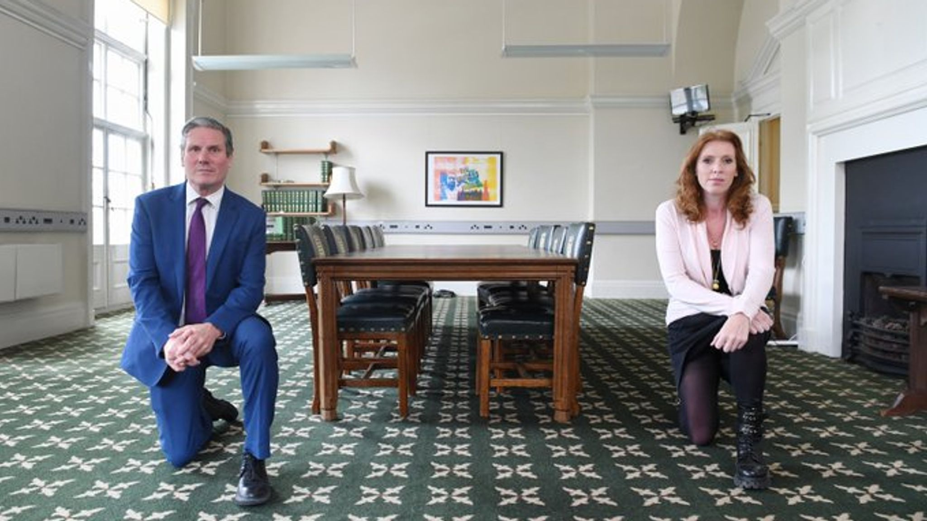
Sir Keir Starmer and Labour Deputy, Angela Rayner, taking a knee in a meeting room in the UK Parliament, June 2020 (Sky News).

Consider the spectacle of Labour leader, Sir Keir Starmer, genuflecting in solidarity with Black Lives Matter, and note that in his former role of Director of Public Prosecutions, Starmer arranged overnight courts to maximise prosecutions in the aftermath of the London Riots of 2011 (@libcom.org). In transcribed form Shadey’s speech would seem to share the affirmative language of statements released by public institutions at this time, his performance of kneeling dovetailing with this kind of state appropriation. On the contrary, Shadey’s call definitely swerves away from this order of spectacle as Black performance. Reading with Christina Sharpe, I argue that Shadey performs otherwise, with a difference. As she proposes: ‘The asterisk after a word functions as the wildcard, and I am thinking of the trans* […] as a means to mark the ways the slave and the Black occupy what Saidiya Hartman calls “the position of the unthought” (Sharpe 30).
Sharpe is here in conversation with a community of Black feminist scholars through a shared citational practice. Her use of the asterisk responds to Hortense Spillers’s call for an ‘insurgent ground’ in the wake of the fact that, as Spillers has written, ‘every feature of social and human differentiation disappears in public discourses regarding the African-American person’ (78). Sharpe’s expression of forms of occupying what Hartman calls ‘the position of the unthought’ points to improvised styles and effects of movement in speech, the prefix trans* serving to ‘enable’, as Sylvia Wynter has written, ‘the rhetorical energy of black nationalist discourse so powerfully “to mobilise the sign of blackness” (111). Just as the uniformity of kneeling is surrogated in Shadey’s performance, per King’s genealogy, so is his speech; uttered in this context, the word ‘unity’ follows a different logic. As Denise Ferreira Da Silva, in dialogue with Wynter, observes, ‘traversability […] assumes linear causality, the existence of different points in time, but does not obey its limitation, which is efficient causality’ (94). While Shadey’s performance and speech is patterned after liberal discourse, to read the Eurocentric universalism of ‘unity’ into his call for unity* would be to ignore his Black performance, defined by capacities of ‘rhetorical energy’ and ‘traversability’.
More precisely, we can say that where kneeling has been choreographed into a stale neutrality by state actors like Starmer, it is in this context a migratory gesture with a specific genealogy tied to blackness, as that which traverses Shadey’s call for unity*, mobilising those assembled via a contagious act of ‘vibratory potential’. This gesture may have been absorbed by the choreography of the state, its immobilisation of the subject rendering them docile, yet Shadey is a Black man, representing the ‘constitutive outside’ of the liberal message of unity that kneeling serves. Of course, Black people constitute docile citizens in contemporary social life too. However, a confrontation of anti-Black violence allows us to grapple with the antagonisms made visible by the call for unity* amid lockdown. His performance dislocates this gesture from its state-sanctioned codification, linking it to a wider gestural economy that indexes ‘the sociopoetics of the riot’.
At issue is the ubiquitous slogan ‘White Silence is White Violence’ and its mediagenic uptake by the state. For this slogan is a demand appealing to white empathy. It entails a mode of identification that, as Saidiya Hartman has proposed, ‘is as much due to […] good intentions and heartfelt opposition to slavery as to the fungibility of the captive body’ (Scenes of Subjection 19). Whether felt by the 19th-Century abolitionist or the contemporary white liberal, Hartman argues that empathy with the plight of the dispossessed conceals a pleasurable means of taking possession of the other; in her view, the sincere projection of feeling establishes a kind of ‘disembodied universality’ that is ultimately consonant with mastery of the enslaved in ‘the aftermath of slavery’ (21). In structure, this slogan is a demand by white people that puts the spotlight on white people to end the liberal toleration of violence against Black people. Yet, in its fantasised address to the inwardness of the citizen, this slogan’s psychic investment arguably draws on the same kind of moral censure that has, under other circumstances, led white liberals to fixate on the violence of young Black men.
Simply put, ‘violence’ is a constitutive agent of racialisation that is not overcome by the mobilisation of white leftists; the murder of George Floyd establishes a hermeneutic circle, its spectacularised violence reinscribing white liberalism as structurally dominant. This slogan’s abstract invocation of violence is inseparable from the fact that, as Sharpe after Frank Wilderson III has written, ‘it is gratuitous violence that occurs at the level of a structure that constitutes the Black as the constitutive outside’ (Sharpe 28) – Afropessimism, in short, argues that ‘gratuitous violence’ is necessary in modern society to ‘secure the division between the Human and the Black’ (Wilderson). As Wilderson goes on to report, this analysis grew out of a frustration with ‘multiracial coalitions’ and the recognition that the historical specificity of anti-Black violence was often sidelined by activists. In this sense, the slogan ‘White Silence is White Violence’ vitiates the production of a coalitional politics. However, precisely because of its reliance on embodiment, this logic of dispossession may be subverted by moments of contagion.
I want to close by suggesting that Shadey’s call for unity* is effective in swerving away from liberal discourse. His invitation to kneel, which passed through the crowd, redirected the energies of this ‘linear causality’, producing a different kind of collective, Whether you’re black, whether you’re white. Whether you’re Asian, or whether you’re anything, do not be shy. Shadey’s call opens the door to another kind of interaction, one that seeks to move beyond the fixity of white liberal guilt. Like an invitation to dance, do not be shy encourages self-exposure. A friend recently asked if I had been in touch with Shadey. Realising there was a gap in communication, I sent him a message on Instagram. What had seemed obvious to my friend, coupled with the lack of a reply from Shadey, made me reflect on my own positionality and actual distance from coalitional work. Shadey’s call figures the protest as a site of struggle and unlearning. The difficulty of sustaining a painful contact with the tarmac, ‘where performance meets ontology’, submitted the crowd as a whole to the experience of downward mobility and social dispossession (Marriott 40), a gravitational pull that brought mystified bonds of white empathy and privilege to the surface. As such, I argue that the doing of ‘taking a knee’ is other than its circulation as a sign of unity; ‘vibratory potential’ itself mobilising a coalition in action.
A history of ‘interdicted movement’ was transmitted through the balancing act of taking a knee, untethering this gesture from its representation by the state, so that when the protestors stood up, social movement was produced. Following Bradley, we can say that kneeling’s choreographed fixity was disrupted by its transmission as Black performance, producing unity through contagion. Further, Shadey’s call intervened into the government lockdown, reconfiguring the social organisation of the street. In this sense, kneeling joins other scenes in the protests that produced similar contagious moments of solidarity.
At the end of one protest in June, someone shouted “let’s march to Grenfell!” The unplanned march from Battersea to Kensington was obstructed by police at several points but the protest did reach Grenfell Tower. On 14 June 2017, a fire broke out in Grenfell Tower, a council estate in West London, killing 72 residents. This tragedy brought the Tory Government’s racist austerity politics into sharp relief, as the fire was a direct result of legislative decisions not to carry out necessary social work. Led by a grassroots campaign, a silent walk was held each month after the fire.
In the late afternoon sun, everyone sat in small circles on Latimer Road while twenty metres away, a caravan of riot vans were parked, the police observing. This assemblage of circles of tired protesters, as well as the historic spectacle of a protestor kneeling on the bronze, shit-covered slave trader’s neck in Bristol, join Shadey’s performance to produce a newly radical set of demands that are inseparable from the experience of euphoria and grief.

Works Cited

Akhabau, Izin. ‘Black men aged 18-24 are 19 times more likely to be stopped and searched in London.’ The Voice, 3 December 2020. <https://www.voice-online.co.uk/news/uk-news/2020/12/03/black-men-aged-18-24-are-19-times-more-likely-to-be-stopped-and-searched-in-london/> Accessed 12 December 2020.

Bradley, Rizvana. ‘Black Cinematic Gesture and the Aesthetics of Contagion.’ TDR: The Drama Review 62.1 (2018): 14–33.

Cone, James, Black Theology & Black Power. Orbis Books, 2019.

Da Silva, Denise Ferreira. ‘Toward a Black Feminist Poethics: The Quest(ion) of Blackness Toward the End of the World.’ The Black Scholar, States of Black Studies, 44.2 (2014): 81–97.

Hall, Stuart. Policing the Crisis: Mugging, the State, and Law and Order. Macmillan, 1978.

Hartman, Saidiya. Wayward Lives, Beautiful Experiments: Intimate Histories of Riotous Black Girls, Troublesome Women and Queer Radicals. Serpent’s Tail, 2019.

---. Scenes of Subjection: Terror, Slavery, and Self-Making in Nineteenth-Century America. Oxford University Press, 1997.

---. ‘Venus in Two Acts.’ Small Axe, 12:2 (2008): 1-14.

James, Joy and João Costa Vargas. ‘Refusing Blackness-as-Victimization: Trayvon Martin and Black Cyborgs.’ Pursuing Trayvon Martin Historical Contexts and Contemporary Manifestations of Racial Dynamics. Eds. George Yancy and Janine Jones. Lexington Books, 2014.

Jason, King. ‘Which Way is Down? Improvisations on Black Mobility.’ Women & Performance: A Journal of Feminist Theory, 14:1 (2004): 25–45.

@libcom.org. ‘In 2011 Keir Starmer ran all night courts as Director of Public Prosecutions to maximise the number of people prosecuted after the London riots. Twitter. 10 Jun. 2020, 8:45 a.m., <https://twitter.com/libcomorg/status/1270623055325298689?lang=en>.

Marriott, David. ‘Corpsing; or, The Matter of Black Life.’ Cultural Critique, Number 94 (2016): 32–64.

Moten, Fred. In the Break: The Aesthetics of the Radical Black Tradition. Duke University Press, 2003.

‘My speech at the London protests #BLM.’ YouTube, uploaded by Still Shadey, 23 June 2020, <https://www.youtube.com/watch?v=XIkMoYAUnSw> Accessed 12 December 2020.

Robinson, Cedric. Black Marxism: The Making of the Radical Black Tradition. University of North Carolina Press, 1983.

Sharpe, Christina. In the Wake: On Blackness and Being. Duke University Press, 2016.

Spillers, Hortense. ‘Mama's Baby, Papa's Maybe: An American Grammar Book.’ Diacritics 17:2 (1987).

Wilderson III, Frank. “Frank B. Wilderson III in Conversation with Aria Dean.’ Interview by Aria Dean. November Magazine, 7 August 2020, <https://novembermag.com/contents/2>.

Wynter, Sylvia. ‘On How We Mistook the Map for the Territory, and Re-Imprisoned Ourselves in Our Unbearable Wrongness of Being, of Désêtre: Black Studies Toward the Human Project.’ Not Only the Master’s Tools: African-American Studies in Theory and Practice. Eds. Lewis R. Gordon and Jane Anna Gordon. Paradigm Publishers, 2006.

I found a video of Shadey’s speech on YouTube while researching for this essay and after attending the protests. His channel features music videos mixing genre codes of grime and drill, alongside social commentary. I here take his protest speech as exemplary in its emotional communication of key issues around anti-Black racism.
Contagion has provided a metaphor for describing the crowd from Gustav Le Bon (1895) onwards. In this essay contagion is linked to the gesture of Black social dance.
Edward Colston (1636-1721) was a notorious British slave trader. In his official role in the Royal African Society, he was responsible for the enslavement and forced transportation of thousands of Africans during the Transatlantic Slave Trade. His statue was toppled and then dumped in the harbour by Black Lives Matter protesters.
As João Costa Vargas and Joy A. James ask, ‘What happens when, instead of becoming enraged and shocked every time a black person is killed in the United States, we recognise black death as a predictable and constitutive aspect of this democracy?’ (193).
For instance, see James H. Cone’s Black Theology & Black Power (1969).
See Stuart Hall and others’ important analysis of mugging and moral panic.
As Cedric J. Robinson writes, ‘The creation of the Negro was obviously at the cost of immense expenditures of psychic and intellectual energies in the West. The exercise was obligatory. It was an effort commensurate with the importance Black labor power possessed for the world economy’ (4).
While acknowledging the contested position of Afropessimism within Blackness Studies, I introduce this critical framework here as Black Lives Matter is a coalitional movement centred on anti-Black violence.
I am indebted to Akshi Singh for this thought.
Thank you to Gabriella Okon making this point.

